|  |  |  |
| --- | --- | --- |
| **Ex. No. 2** | **Implementation of Arrays** | |
| **Date of Exercise** | | 01-12-2017 |

**Aim:**

To develop Java programs for the following problems:

1. Write a Java program to print summation of odd numbers and even numbers in an array.

2. Write a Java program to merge two arrays into third array.

Note:

Declare three one dimensional array.

Get input for first two arrays from user.

Use any loop (for/while) to merge first two arrays into third array.

3. Write a java program to sort the array and find second minimum and second maximum value in an array.

4. Write a java program to find common elements between two arrays.

5. Write a java program to sum of diagonal of matrix (multidimensional array).

**Algorithm:**

**1.To print summation of odd numbers and even numbers in an array.**

1. Start.
2. Declare three integer variables i, sumev=0 and sumod=0.Also declare an integer array.
3. Get the array elements from the user using scanner class.
4. Initialize a for loop which starts from i = 0 till i < 5.
5. Inside the loop, using if check whether a[i] % 2==0, if it is so add that number to sumev, else add it to sumod.
6. Display the result.
7. End.

**Source Code:**

package exp2;

import java.util.Scanner;

public class arrsum {

public static void main(String[] args) {

int i;

int sumev=0;

int sumod=0;

int a[]=new int[5];

Scanner s=new Scanner(System.in);

System.out.println("Enter the array elements: ");

for(i=0;i<5;i++){

a[i]=s.nextInt();

}

System.out.println();

System.out.println("The array elements are: ");

for(i=0;i<5;i++){

System.out.print(a[i]);

System.out.print(" ");

}

System.out.println();

for(i=0;i<5;i++)

{

if(a[i]%2==0)

sumev+=a[i];

else

sumod+=a[i];

}

System.out.println();

System.out.println("The sum of even numbers are: "+sumev);

System.out.println();

System.out.println("The sum of odd numbers are: "+sumod);

}

}

**Input & Output:**

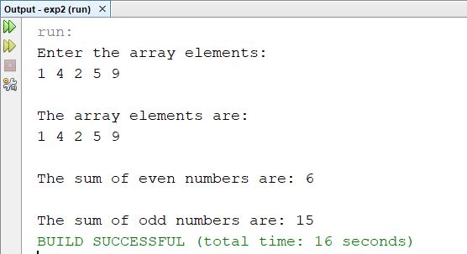

**Algorithm:**

**2.To merge two arrays into third array.**

1. Start.
2. Read two arrays from the user and third array to display the merged array.
3. Initialize two for loops and pass the values to the third array.
4. Display the result.
5. End.

**Source Code:**

package exp2;

import java.util.Scanner;

public class mergearr {

public static void main(String args[]){

int i;

int a[]=new int[5];

int b[]=new int[5];

int c[]=new int[10];

Scanner s=new Scanner(System.in);

System.out.println("Enter the first array elements: ");

for(i=0;i<5;i++)

{

a[i]=s.nextInt();

}

System.out.println("Enter the second array elements: ");

for(i=0;i<5;i++){

b[i]=s.nextInt(); }

System.out.println();

for(i=0;i<5;i++){

c[i]=a[i];}

int j;

for(j=0,i=5;i<10;j++,i++){

if(j==5)

break;

c[i]=b[j];}

System.out.println("The merged array elements: ");

for(i=0;i<10;i++){

System.out.print(c[i]);

System.out.print(" ");

}}}

**Input & Output:**

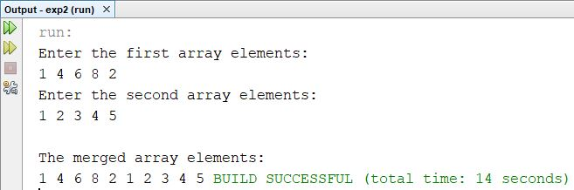

**Algorithm:**

**3.To sort the array and find second minimum and second maximum value in an array.**

1. Start.
2. Declare an array and get the array elements from the user. Initialize a variable count=0.
3. Initialize a for loop from i=0 till i<5 and another for loop from j=1 till j<5.
4. Inside the loop check if a[i] > a[j], if it is so swap a[i] and a[j].
5. Display the sorted elements.
6. To display the second minimum print a[3] and for second maximum value print a[1].
7. End.

**Source Code:**

package exp2;

import java.util.Scanner;

public class sortarr {

public static void main(String[] args) {

int temp;

int i, j;

int a[]=new int[5];

Scanner s=new Scanner(System.in);

System.out.println("Enter the array elements: ");

for(i=0;i<5;i++){

a[i]=s.nextInt();

}

System.out.println();

System.out.println("The array elements are: ");

for(i=0;i<5;i++)

{

System.out.print(a[i]);

System.out.print(" ");

}

System.out.println();

int count=0;

for(i=0; i<5; i++)

{

for(j=i; j<5; j++)

{

if(a[i] > a[j])

{

temp=a[i];

a[i]=a[j];

a[j]=temp;

}

} }

System.out.println("The sorted elements are: ");

for(i=0;i<5;i++)

{

System.out.print(a[i]);

System.out.print(" ");

}

System.out.println();

System.out.println("The second minimum element is: "+a[1]);

System.out.println("The second maximum element is: "+a[3]);

}

}

**Input & Output:**

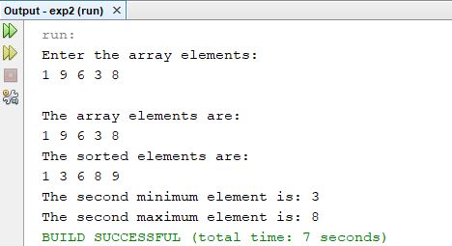

**Algorithm:**

**4.To** **to find common elements between two arrays.**

1. Start.
2. Initialize two arrays and get the input from the user. Declare a variable cnt and initialize it as 0.
3. Initialize two for loops from i=0,j=0 till i<5,j<5.
4. Inside the loop, check if a[i]=b[j],if so increment cnt and display the element.
5. Then check if cnt==0, if it is so display “No common elements found”.
6. End.

**Source Code:**

package exp2;

import java.util.Scanner;

public class commonarr {

public static void main(String[] args) {

int i, j;

int a[]=new int[5];

int b[]=new int[5];

Scanner s=new Scanner(System.in);

System.out.print("Enter the first array elements: ");

for(i=0;i<5;i++)

{

a[i]=s.nextInt();

}

System.out.print("Enter the second array elements: ");

for(i=0;i<5;i++)

{

b[i]=s.nextInt();

}

System.out.println("");

System.out.print("The first array elements are: ");

for(i=0;i<5;i++)

{

System.out.print(a[i]);

System.out.print(" ");

}

System.out.println("");

System.out.print("The second array elements are: ");

for(i=0;i<5;i++)

{

System.out.print(b[i]);

System.out.print(" ");

}

System.out.println();

System.out.println("");

int cnt=0;

System.out.print("Common elements between two arrays: ");

for(i=0;i<5;i++)

{

for(j=0;j<5;j++)

{

if(a[i]==b[j])

{

cnt++;

System.out.print(a[i]);

System.out.print(" ");

}

}

}

if(cnt==0)

System.out.println("Not Found!!!");

}

**Input & Output:**

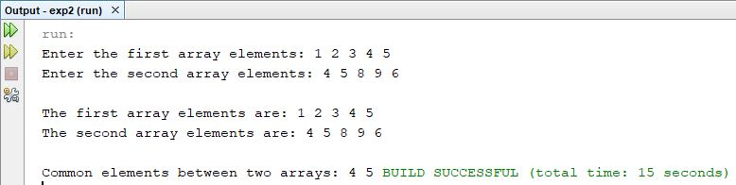

**Algorithm:**

**5.To find the sum of diagonal of matrix (multidimensional array).**

1. Start.
2. Initialize two-dimensional array and get the number of rows and column from the user.
3. Get the array elements from the user.
4. Initialize two variables sum1=0 and sum2=0, initialize a for loop j=0 till j<a.length and calculate the sum1 as sum1 + =a[j][j].
5. Now, initialize k=a.length-1, then initialize another for loop from j=0 till j<a.length and if k>=0 calculate sum2 as sum2 + =a[j][k], then decrement k inside the loop.
6. Display the result as sum1 and sum2.
7. End.

**Source Code:**

package exp2;

import java.util.Scanner;

public class diagsum {

public static void main(String args[]){

Scanner scanner = new Scanner (System.in);

int rows;

int columns;

System.out.print("Enter number of rows: ");

rows = scanner.nextInt();

System.out.print("Now enter the number of columns: ");

columns = scanner.nextInt();

System.out.println("");

int a[][] = new int [rows] [columns];

for (int i = 0; i < rows; i++) {

for (int j = 0; j < columns; j++) {

System.out.print("Enter the number for row " + i + " and column " + j + " : ");

a[i][j] = scanner.nextInt();

}}

int k=0;

int j=0;

int sum1=0,sum2=0;

for(j=0; j < a.length; j++){

for(k=0; k < a.length; k++){

System.out.print(a[j][k] + " ");}

System.out.println();}

for(j=0; j<a.length; j++) {

sum1=sum1+a[j][j];

}

k=a.length-1;

for(j=0; j<a.length; j++) {

if(k>=0){

sum2=sum2+a[j][k];

k--;

}

}

System.out.println("Sum of Diagonal elements are :" +sum1+ " and "+sum2);

}

}

**Input & Output:**

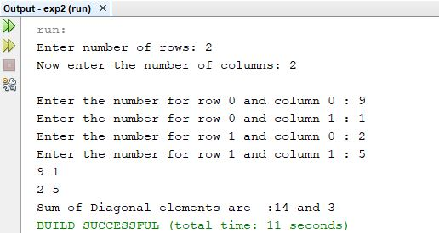

**Video URL:**

**<https://www.youtube.com/watch?v=3mJr1CwWSOs&feature=youtu.be>**

**Result:**

The program to do the implement array programs is implemented successfully and the output is verified.